Prior to showing the website, I’d like to include a page to gather information from the person who makes the request.

The page would be like below.

**ASSIST Functional Performance Index**

Thank you for your interest in the ***ASSIST Functional Performance Index.*** Please fill out the following form to be directed to the site where you can review and try out the tool. We keep all of your information completely private.

First Name

Last Name

Organization/Company

Your Role in the Organization/Company

Zip Code

Email

How did you hear about this tool?

What population(s) do you serve (e.g., disability type, older adults etc.)?

Why are you interested in this tool?

Newsletter

Please sign me up to receive the Wireless RERC newsletter

Submit

On this page, here is the example layout.

**INTRODUCTION**

The ASSIST Functional Performance Index (AFPI) is designed to assess the ability of an individual to complete everyday tasks which smart technologies (e.g., smart home devices, smart speakers/displays, smartphones and apps) could potentially provide assistance to support their performance and participation.

The AFPI includes a list of 46 tasks in 6 domains including Environmental Control (9 tasks), Activities of Daily Living (ADL) (5 tasks), Instrumental Activities of Daily Living (IADL) (20 tasks), Communication and Planning (6 tasks), Leisure Activities (4 tasks), Emergency Management (2 tasks). Individuals answer a series of questions to indicate 1) how they complete each task, 2) the amount of assistance or effort required to complete each task and 3) their satisfaction with how each task is completed. They would answer the questions based on how they most commonly complete each task.

The AFPI was evaluated for test-retest reliability at the item level and construct validity for the overall score with respect to two validated tools including Spinal Cord Injury Functional Index (SCI-FI) Self Care Short Form (SF) and SCI-FI Basic Mobility SF in 22 individuals with physical disabilities. The detail of the AFPI development and evaluation is summarized in a manuscript currently in review with *Assistive Technology*. If the manuscript is accepted, we will update this section by providing a link.

Please note that the AFPI item bank was developed for people with physical disabilities, and thus may not include tasks that are relevant to people with other types of disabilities. Also, as smart technologies evolve, the item bank could be further expanded.

**RECOMMENDED USE**

While one can administer AFPI as a whole to assess the functional independence of an individual on the everyday tasks included in the tool as well as their satisfaction, this tool is more suitable for supporting client-centered technology-based interventions – identifying user needs and assessing their performance before and after the interventions. On the next page, we provide a web-based tool for using the AFPI to identify user-defined priorities and assess their baseline performance. You will need to create an account in order to try it out.

TASK

**Tap a Category**

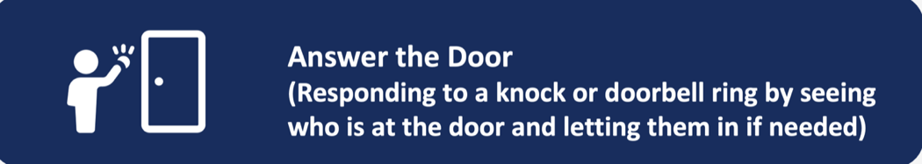Please sort each card into the category that makes sense to you. Do what comes naturally. There are no wrong answers.

**I do not do – don’t want to do**

**I do now with no problem**

**I do now with difficulty**

**I do not do but wish to do**

Continue

Terminology

* Card – refers to a jpeg or png file, which has an icon or picture plus the text descriptions, just like the blue box above. The cards could be pre-made by the researchers, and should be all in the same size.

On the backend, here are the functions we would need

* Upload cards
  + Each card will have a jpeg/png file and also a short description. For example, the blue box above is a jpeg/png, but it also has a short description “Answer the door” to associate with it.
  + There should be a function for researchers to upload each card and provide the short description.
  + There should be a function for researchers to specify which cards will be loaded to show on the screen.
* Move cards into the four bins
  + When moving the cards to the bin, only the short description gets to add to the bin instead of the jpeg or png, which will not take much space and can be viewed easily.
  + In terms of moving cards to the bins,
    - Option 1: as each card shows up, users could drag the card to the bin they want and then drop it there.
    - Option 2: as each card shows up, users can simply click anywhere on the bin to indicate the card would go to that bin. Also the bin should change color as it is clicked so it is easily to tell visually that bin is the target.
    - Text

      Description automatically generatedOption 3: as each card shows up, users can click the card and then a menu shows up to indicate the four bins and users can select one and that item will go to the corresponding bin.

I do not do – don’t want to do

I do now with no problem

I do now with difficulty

I do not do but wish to do

* As the item are adding to the bin, the size of the bin needs to automatically extend to accommodate all the items to be shown in one screen. Do not use scroll for users to see more.
* Users can also select an item inside a bin to remove it from the bin.
  + Option 1: Drag and drop. Drag it out of the bin to drop it to the card area.
  + Option 2: Click the item in a bin, and a side menu pops up “Remove”. Once select “Remove”, the corresponding card will show up in the card area.
* On the top, it shows the progress. First presenting the top number of card, as the card goes into the bin, the number decreases. If the card was removed from a bin, the number will increase.

After they click “Continue”, we will show the next page.

TASK

**Prioritize Your Needs**

Please take a look at the tasks you’ve sorted into two of the categories which you may need help with. Rank the top # based on your priorities. We will help you address these priorities using smart technologies. There are no wrong answers.

**My Priorities**

**I do not do but wish to do**

**I do now with difficulty**

Move UP

Move DOWN

Task 2 ………………………..

Task 4 ………………………...

Task 12 ………………………

Task 24……………………….

Task 3 ………………………..

Task 6 ………………………...

Task 11 ………………………

Task 20……………………….

Sd

Remove

On the backend, here are the functions we would need.

Continue

* Add items to the priority bin
  + Option 1: Drag and drop
  + Option 2: As users click each item in the two categories, it will show in the priority bin.
* As the items go into the priority bin, it will be ranked with a # in front of each task
* When users click the item in the priority bin,
  + Option 1: Drag and drop. Drag is up and down to re-rank. Drag it back to the original bin
  + Option 2: it will show a menu on the side with options [move up, move down, remove] as shown in the picture
* It will limit the number in the priority bin by the number pre-defined. If we say Top 10, then the number should be capped at 10. If users want to add more to the priority bin, it will pop up a window to notify them that they are at the limit now and need to remove an item in order to add a new one.
* I guess the number, the card upload function, select what cards to show could be all set up in a configuration page.

After they click “Continue”, we will show the next page.

TASK

**Rate Your Performance**

For your top # priority tasks, please rate

* how important the task is to you from 1 to 10
  + 1 – not important at all
  + 10 – extremely important
* how well you can do the task
* how satisfied you are with the task is completed

Task 1: …………………………………………… [load the corresponding card here]

How important this task is to you for 1 to 10?

1 – not important at all

2

3

10 – extremely important

How do you complete this task?

If select first and second choice from the 2nd question, ask the following one.

 How much assistance do you require to complete this task?

If select third and forth choice from the 2nd question, ask the following one.

 How much effort is required for you to complete this task?

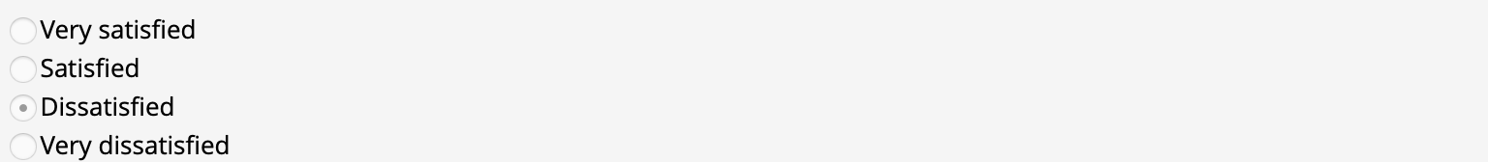 How satisfied are you with how you complete this task?

Comments

[The questions for each task will be shown on by one on the same page. The only contingency is based on question #2 and you can present either question #3 or #4. Question #5 on satisfaction should always be asked]

Next Task

After all the top # tasks, present a table of summary like below.

|  |  |  |  |  |  |
| --- | --- | --- | --- | --- | --- |
| **Task** | **Client Self-Report** | | | | **Notes** |
| **Importance** | **Completion** | **Assistance/Difficulty** | **Satisfaction** |
| Task 1 ……  ……  …… | 6 | On my own tech | Difficult | Satisfied |  |
| Task 2 ….. ……… | 10 | With assistance person and tech | Complete assistance | Not satisfied |  |
|  |  |  |  |  |  |
|  |  |  |  |  |  |
|  |  |  |  |  |  |

As smart technologies continue expanding, they could support more everyday tasks. We’d like to grow the item bank to address the challenges people with disabilities face. If you encounter other items that have a mainstream technology solution, please share with us in the box below.

Comment/feedback, join a group, if they want to use the web-based AFPI tool.